**Chapter 1 Introduction**

**1.1 Problem Statement**

The problem domains on this project are:

1. **Bloated software and user interfaces**

Due to the fierce competition between music player applications, many developers tried to add many features, advertise, and content to their respective music player in order to retain their users and attract new users. This trend has made it harder for users to get content from their music player, which also means it is harder to filter the content that they want. With the continuous iteration of application and a growing number of features, the music player will become even more bloated and the user's experience will become less smooth. Users tend to feel frustrated and angry if they take a long time to get a reply from the mobile application, so they will never return to the same application, and 48% of users will simply uninstall or stop using it.

1. **Lack of gestures to control**

Most music player apps use touch buttons to play, pause and switch between previous and next songs while ignoring the convenience of using gesture swiping to control the music player. For instance, when a user is working and intends to skip to the next song in the music player, he/she must switch their attention to the console from work and click the button. This problem does not affect music player properly work, but it does have some inconvenience. However, according to Scacca (2020) said that as our physical devices and appliances develop the button-free design, consumers will become more comfortable and

confident in this way of interaction, so we should consider using gesture control on more mobile applications

1. **Lack of sorting and searching features**

When users continuously to add new songs into the playlist, the difficulty of the songs the user wants to filter will increase. After the songs in the playlist are added to reach hundreds of songs, the user can only search song by continuously swipe up or down. If not carefully check the content, it is possible to miss the songs that the user wants to filter, and then repeat the behaviour until the result is found. Therefore, it is an extremely poor experience for users.

**1.2 Background Information and Motivation**

In modern society, people live a fast-paced life, and pressure is constantly present in lives. Due to the wide use of mobile phones, music has become the daily essential spiritual food, everyone's mobile phone inside there must be a music player. An application like MP3 music players is used to balance stress and happiness. It accompanies people anytime, anywhere and anyplace such as when people taking the bus and exercising. The mobile MP3 music player application is designed to allow users to listen to music in a more convenient and comfortable way without too much restriction. Moreover, it can play the music properly without interference from advertisements and offline. Since many developers realize that modern urbanites are living in a stressful situation, they have captured the commercial opportunity, therefore many similar applications have emerged in the market. These applications have easy-to-use interfaces and features that make the user experience better. However, these existing music players blindly pursue fancy appearance and huge features, resulting in the high utilization rate of users' mobile phones, such as CPU and memory. Whereas, for most normal users, these kind of huge and many features are meaningless. Therefore, this project is designed to dedicate to MP3 music player based on the Android mobile phone platform to optimize performance and simplify to meet user needs.

**1.3 Objectives**

The objective of this thesis is to propose development of android that:

1. **Make it with a simple feature and run smoothly**

By using this mp3 music player will make users feel comfortable and relaxed because it will pay more attention to the features commonly used by users, excluding some rarely used features that occupy a large of system processors, making the music player lightweight, simple, but also has powerful basic features.

1. **Support gesture control**

The MP3 music player will add features triggered by gestures to make it easier for users to use as well as less dependent on touch buttons. For example, a user can skip next or previous songs by simply swiping left and right on the anywhere of the screen in the playing interface.

1. **Support quick search**

The lack of a search bar in the music list is unacceptable. Therefore, the mp3 music player will use the search bar as well as fast scroll using alphabets on the right side of the screen, allowing users to quickly filter through hundreds of songs to find the ones users want to play.

**Chapter 2 Literature Review**

**2.1 Review on existing application**

**2.2.1 Review on Spotify music**

Spotify is a free music player that can play all music on YouTube, support background playing music, and download the song into local storage for free. Its music library is extremely powerful that covers almost all songs, such as English, Chinese, Cantonese, Japanese and even Korean songs. It performs extremely well in terms of functionality and interaction between users and application. The homepage of Spotify is ‘Discover’, in which random lists and popularity rankings of various music themes are provided such as rank, latest songs, and weekly. When users feel confused in selecting songs or tired of listening to classic songs, this feature allows users to directly click, listen to the latest music.

Furthermore, the search page of Spotify supports searching according to the singer, song name, album, and others, enabling users to quickly find favourite music songs. The search page also has popular search keywords and recent search history records, make search feature more user-friendly and easier.

In the playback control interface, the top is music video playback. However, it is not supported by playing the music only, but there is a "Save traffic" on the top right. Below is the playlist of songs, if users prefer to the music, it is allowing to download the song by clicking "Download" button which next to the song title and selecting the file format. There are two formats can be chosen, which are MP3 and MP4. The downloaded MP4 files can be viewed offline.

There is an option which is the 'Add' button next to the song title, it represents to add the song to the playlist created by users. In "My Music" page, users can create their own music world by adding favourite songs into the playlist. All playlists are free to create and unlimited in number. In the meantime, users can decide on the cover page of the playlist by placing the song on the first ordering. Unfortunately, local songs in the storage of the phone cannot be added in the playlist, only songs downloaded from Spotify can be added.

Moreover, there is an FM radio feature in Spotify. Users can directly choose channels to listen to music recommended by the system and may hear some unexpected and favourite songs here.

In Spotify setting, users can choose whether to enable the floating window display features. The floating window is achieved by covering the top of all applications, so no matter on the desktop or running any applications, the MV screen of music will be displayed, and the position can be dragged arbitrarily.

In addition, there is a timer feature that allows users to fall asleep while playing their favorite songs without worrying about the huge amount of cellular data that might be consumed by continuous playing the whole night.

In conclusion, Spotify is an excellent music player that can meet many requirements of users and run smoothly. Spotify has a neat user interface, making simplicity exquisite and beautiful. However, it is a completely free music player, so there is a lot of advertisement on many pages. But it can be turn off advertisement by pressing back button on the phone, which is better than having to watch an advertisement for a mandatory 30 seconds in many applications

**2.1.2 Review on Saavan Music**

Saavan music is a music player application owned by Hangzhou Alibaba Music Technology Co., Ltd. Saavan's design team is a group of people who love music and life. They started the development of Saavan music in the year 2006. In the early days, Saavan music was also called "EMUMO", meaning earn music and money. So far, Saavan music's efforts and professionalism have been recognized by many users, with 14.4 million active users in China every month. In addition, Saavan has also been committed to supporting original music for a long time. It takes the lead in launching original music supporting projects in China to explore and cultivate a new generation of artists for the music industry.

sic main page is to adopt the frameless and blank leaving design looks very comfortable.

However, due to the amount of information on likes and comments in the music community, a large number of blank-leaving design make the visual experience lack hierarchy and increase reading difficulties. Therefore, the divider line can be used in the music community to divide each user's messages. The dividing line represents a wall, which can be used to categorize disorganized information.

Four categories are found at the top of Saavan music main page, which are a library, discover, video and news. The different genres in a music library are categorized clearly, which makes people feel the professionalism and dedication of Saavan music team. It's almost like an encyclopaedia of the music genre, there are even several subcategories for each genre.

In addition, the discover page is to recommend various playlists to users by system. In the discovery page, the users can be swipe down indefinitely, different content will be automatically loaded and refreshed, which makes users have an endless sense of freshness in the music world.

However, as we see that due to the recommended content occupies too much space of screen so that users need to constantly swipe down to see more content, which makes filtering content less efficient. Hence, it can be improved by narrowing the space of each content. For example, there is around two or three new contents on a discovery page, so users can explore and access more music libraries, and can find what they want more quickly and conveniently

In addition, video page is about music video of popular artists. This is because the short video clips are popular now, therefore, it is a feature that launched to meet some users. Finally, the news page is about some famous stories of some composers and singers as well as the latest news in the music field.

The feature which is driving mode and night mode in Saavan music is noteworthy. When the user enabled driving mode, the buttons in the playback control screen will become very large, which allows the driver to control the music player without distraction while driving and more convenience. In addition, there are three song lists can be chosen in this mode that is the radio station, recently played songs and the local music.

Moreover. night mode is about the background colour of the music player interface will be changed to black, which is to meet the bad habit of modern people still playing mobile phone after turning off the light, so that when they use the music player in the dark environment, the light in the phone will not be so dazzling.

Summary, Saavan music compared to other music apps, it is more emphasized on the experience of listening to music, like a specially prepared for those who love music. It has a neat user interface, no additional unnecessary features due to it is a music player, so listening to music is the most main features

**2.1.3 Review on SoundCloud Music**

SoundCloud, owned by Tencent Mobility Limited is a streaming music service APP launched in 2015. Its main markets are Hong Kong, Malaysia, Indonesia, and Thailand, and it is the most downloads music player application across Google Play and IOS (Mulia, 2018). In addition to the existing multiple features, SoundCloud continuously listens to the voice and feedback of customers and launches new features to satisfy users. The SoundCloud user interface is simple and grouped into three groups which is me, discovery and live. On top of each interface, there will be a search bar, allowing users to search favorite songs at any time, has a good interactive.

In the "ME”, users can create a new playlist to manage played and downloaded songs. In addition, SoundCloud will automatically import song on the user's device.

Moreover, one of SoundCloud's features, "My Karaoke”, is a boon for karaoke fans. My karaoke features are very comprehensive after users record their nice songs; they are allowed to preview just recorded songs before saving. Also, users are allowed to edit the recorded songs such as sound offset, vocal or music volume and add effects.

Next, users can search for their favourite songs through various categories on the discovery page. In the artists and playlists under the discovery page, the categories are detailed classification and the layout is neat, just like users stay in a real karaoke room, allowing users to immerse themselves in the music world.

In the radio page, there are around more than 50 theme stations classified according to different song styles, and users can play songs by only one click. Also, the live page is about some artist' interview, live, and their music video.

In addition, the music playback control page with basic functions that users generally need. The layout of the interface is easy to understand and the operation is very simple, which can be mastered immediately after the first use. From show that users can share their favorite songs with their friends at any time. But it has a flaw that users can't rewind and fast-forward freely when playing popular songs because of it is a VIP's privilege.

The biggest drawback of SoundCloud is that many operations require to become VIP, such as downloading or listening to most of the songs. With so many apps out there, that offer free downloads or listen to songs that could drive some users away. So, SoundCloud can introduce some tasks or mission features to relieve the limit once they have done the tasks so that allows users to gain VIP's privileges within a limited time.

To conclude, SoundCloud is comfortable to use, friendly in music classification, and it also allows users to change SoundCloud interface skin freely. It's a great paid music player

## 2.2 Critical Remarks of previous works

### **2.2.1 Strength and Weaknesses of previous works**

|  |  |  |
| --- | --- | --- |
| **Application** | **Strength** | **Weaknesses** |
| Spotify Music | Able to download music on YouTube | Lack of hierarchy in some user interface |
| Saavan Music | Lightweight application and emphasize the experience of listening to music | Annoying ads keep pop up during using |
| SoundCloud | With useful features such as My Karaoke | A large number of features require  VIP privileges |

Table 2-2-1-1 Strength and Weaknesses of reviewed application

**Chapter 3 System Design**

**3.1 Use Case Diagram**

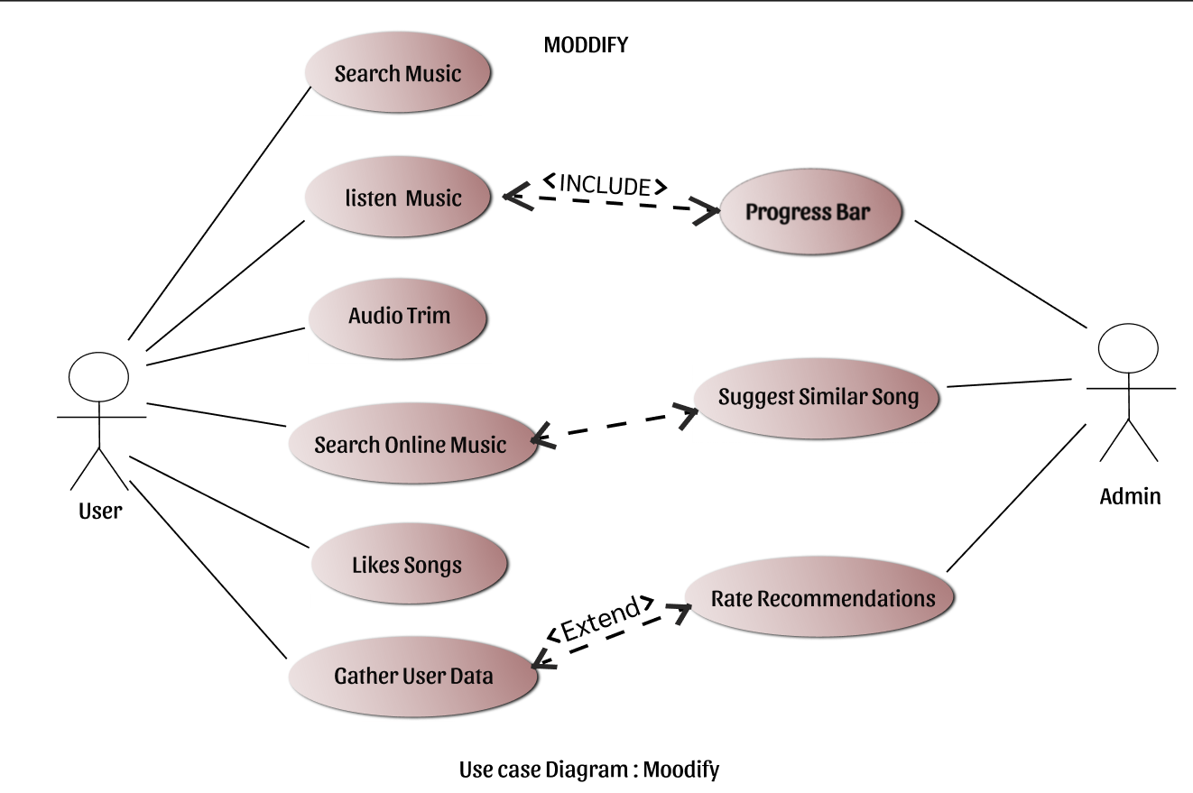

**Use case diagram of Moodify**

**3.2.1 Use Case Description**

|  |  |
| --- | --- |
| Use case name: Listen to music | ID: UC001 |
| Actor: User | |
| Description: User able listen to music on this application | |
| Trigger:   1. User select any song from the playlist 2. User click the play button to start playing the music | |
| Precondition:   1. The user should import the song from their mobile device into the music player 2. The user should add the song into a playlist by search music online feature | |
| Normal flow of events:   1. User select a song from the playlist 2. The song playing until the end | |
| Alternate / Exceptional flows:  1a. The application will display a message "No local music" if the playlist does not have any song | |

**Table 3-2-1-1 Use Case Description of Listen to music**

|  |  |
| --- | --- |
| 1Use case name: Progress bar | ID: UC002 |
| Actor: User | |
| Description: The progress bar shows the progress of the song | |
| Trigger:  1. The progress bar becomes active when the user starts playing the song | |
| Precondition:  1. The song must in playing status | |
| Normal flow of events:   1. Song is playing 2. The progress bar will show the duration of the song 3. The progress bar will be finished if the song is finished playing | |
| Alternate / Exceptional flows:  1a. The progress bar will reset if user play other song  2a. If the user drags the progress bar to left or right, the song's progress will changes 3a. The progress bar will reset if finished playing | |

**Table 3-2-1-2 Use Case Description of Progress bar**

|  |  |
| --- | --- |
| Use case name: Driver mode | ID: UC003 |
| Actor: User | |

**Table 3-2-1-9 Use Case Description of Search music online**

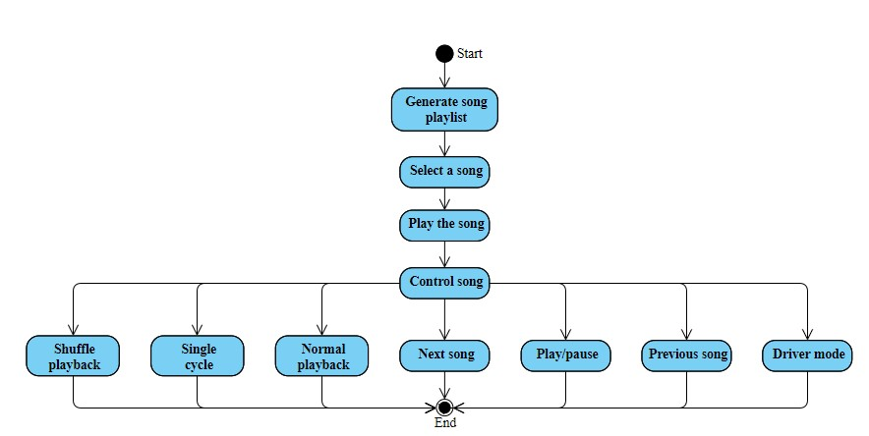

**3.3 Activity Diagram**

**3.3.1 Listen to music**

**Figure 3-3-1-1 Activity Diagram for User to Listen to Music**

The user starts the application and then it will go to the home page which is the "My music" page. The application will read the device's local songs and generate a playlist. After that, the user selects the song and plays it, the page will jump into the playing music interface, where the user is allowed to control the music. Playing modes are allowed to control music play orders which are shuffle playback, single cycle, and normal playback. Moreover, the user can also skip to the next song, back to the previous song and play or pause the current music to control music. Lastly, the user can enable the driver mode to play the song.

**3.3.2 Around you**

**3.3.3 Discover**

**3.3.4 Change Theme**

There are five types of theme colours for users to select. After the user changes the theme colour, the theme on "Spotify" and "" will be updated to the selected colour,

Once you pick your Spotify theme colours, you can update Spotify to import thetheme. First, you need to specify your theme in the configuration file.

You might also note the "colour Theme" option, beneath "current theme." If you create multiple color schemes within a single colour in file, this is where you type the colour

**Chapter 5 Implementation and Testing**

**5.1 Implementation**

The main aim of this project is to play online music and very easily with free of cost. The project "Spotify" after being tested and was found to overcoming all the problems of the existing music player. This music player is found to be error free and ready for implementation.

The proposed web application completed the debugging task during the testing phase, then it should enter the deployment phase. In the deployment phase, the developer needs to host the web application on server which is generate as “Moodify Link”, users can access this web application through "modify link”.

However, due to the number of users are limit so far and the proposed web application is not in the final public version, there are still many modules that should be improved and updated.

Therefore, it will be uploaded to the relevant platform to promote to users after the final public version is released.

Below are the steps to describe how a new user will execute the proposed application:

1.The user first execute the application, he or she needs to give the proposed application the permissions it needs to read local songs on the phone and load them into the song playlist.

2.Users can play a song by clicking on one of the songs on the playlist.

3.In the song playback interface, the user is allowed to drag the progress bar, as well as perform media control through the icon buttons, gesture and shaking the phone.

4. Users can make their own playlist according to their music taste.

**5.2 Testing**

Unit test 1: Music Player

Test Objective: To ensure that the song selected by the user can be played normally, the selected song information is displayed normally, and the song playlist can be import and show properly

|  |  |  |
| --- | --- | --- |
| **Input** | **Expected Output** | **Actual Output** |
| Click "worldwide" in the category | The song playlist under world chart category was successfully read and contains English songs and other songs | Pass |
| Click "pop" in the category | The song playlist under pop category was successfully read and contains English songs and other songs | Pass |
| Choose any song from the playlist | Enter the song playing interface, the song can be playing properly, and successfully display the selected song name, album name and artist name | Pass |
| Play any song and click the home button to make the app run in the background | Songs still playing in the background | Pass |

**Table 5-2-1 Unit Testing of Music Player Module**

Unit Testing 2: Media Icon Playback Control

Test Objective: To ensure that all playback control icon buttons under playing song interface can work and perform properly

|  |  |  |
| --- | --- | --- |
| **Input** | **Expected Output** | **Actual Output** |
| Click the song playback mode to switch to shuffle playback | When the current song finished playing, and it will randomly choose a song from the playlist to play, rather than playing the song in the order of the playlist | Pass |
| Click the song playback mode to switch to the single cycle | When the current song finished playing, just repeat the current song | Pass |
| Click the song playback mode to switch to normal playback | When the current song finished playing, play the song in the order of the playlist | Pass |
| Click the pause button | Stop play the song, the pause button is updated to the play button | Pass |
| Click the play button | Switch to the next song, the song name, album name, and artist name are also successfully updated to the next song's information | Pass |

**Table 5-2-2 Unit Testing of Media Icon Button Playback Control Module**

Unit Testing 3: Driver Mode

Test Objective: To ensure all button and song info under driver playing mode interface will be enlarged and can play the song properly.

|  |  |  |
| --- | --- | --- |
| **Input** | **Expected Output** | **Actual Output** |
| Click driver mode button in the song playing interface | Successfully switch to the driver mode interface, and successfully update the current song playing information | Pass |

**Table 5-2-3 Unit Testing of Driver Mode** **Module**

Unit Testing 4: Around you

Test Objective: To ensure the working of the recommendation of songs.

|  |  |  |
| --- | --- | --- |
| **Input** | **Expected Output** | **Actual Output** |
| Click Around you button in the song | Successfully switch to the around you page, and successfully update the current songs. | Pass |

**Table 5-2-4 Unit Testing of Around you** **Module**

**Chapter 6 Conclusion**

**6.1 Project Review, Discussions and Conclusion**

In a nutshell, when users hold the mentality of venting and relaxation to expect the music player to bring them relief pressure, in result the web application with a dazzling and complex interface, a variety of multifarious functions, from time-to-time prompt out of the advertising, as well as the function that requires be a member to use, which will only make users feel more depressed and feel the pressure. Sometimes user heard a small part of the particular song and music, and user wouldn't able to recognise the song, then this web application will scan those songs secretly and add them to a separate playlist.

In short, the proposed application will combine the strengths of most music players on the existing market and eliminate some unrealistic features, allowing users to focus on listening to music rather than store, communities or various VIP packages or features. The proposed MP3 music player will focus on improving the experience of users of the music player experience.

**6.2 Future work**

In addition, users can login, register and they can make their own music library and can add songs in their library. In future we will add one feature, if the user is going somewhere, then whatever songs and music is playing in the middle of the way, then this web application will recognise them and add those all songs to a separate playlist.

Users can connect with people listening to songs of their choice, and can chat with people.